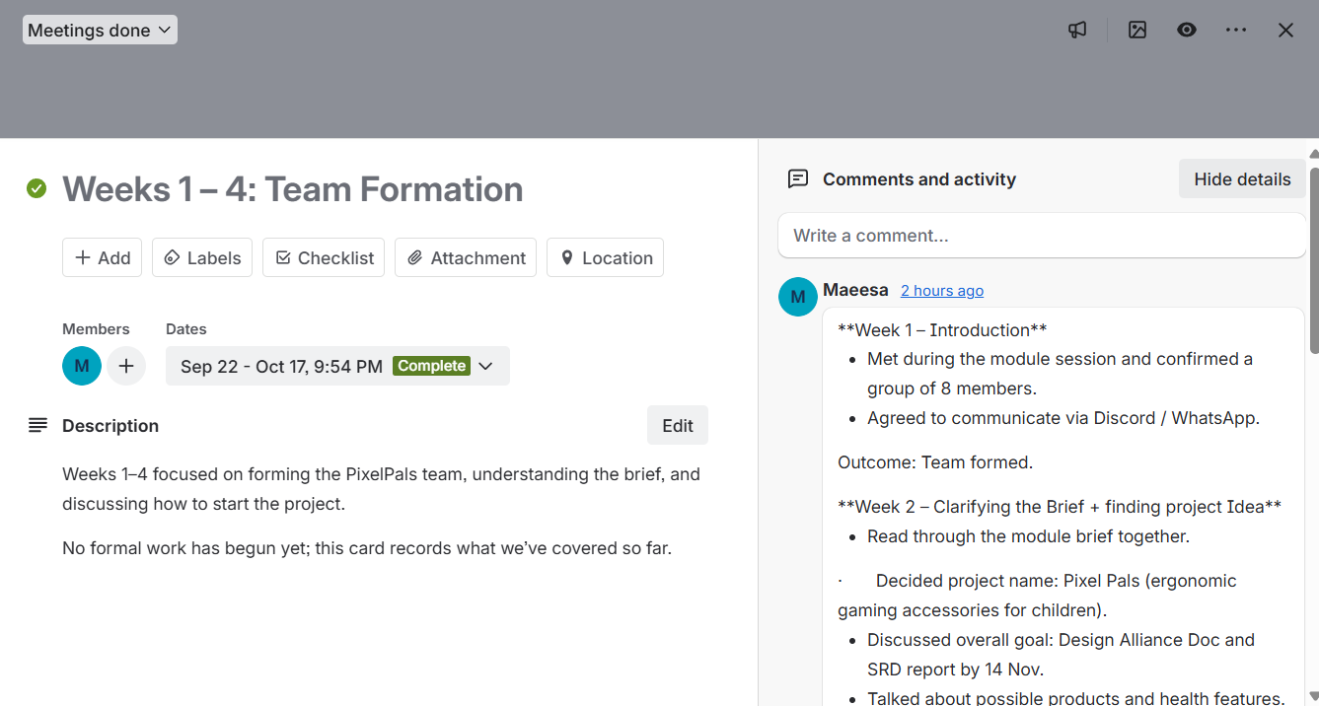

**Week 1 – Introduction**
- Met during the module session and confirmed a group of 8 members.
- Agreed to communicate via Discord / WhatsApp.
Outcome: Team formed.
**Week 2 – Clarifying the Brief + finding project Idea**
- Read through the module brief together.
· Decided project name: Pixel Pals (ergonomic gaming accessories for children).
- Discussed overall goal: Design Alliance Doc and SRD report by 14 Nov.
- Talked about possible products and health features.
Outcome: Project Idea confirmed (Pixel Pals). Everyone understood what Pixel Pals would sell and why.
**Week 3 – Roles and Ideas**
- Brainstormed possible roles from reading about Belbin’s roles.
- Looked at the report sections we’ll need to write.
- Began talking about using Trello and GitHub.
Outcome: Roles identified, tools decided (Trello + GitHub).
**Week 4 – Planning to Start**
- No practical work yet, but the plan agreed to begin in Week 5.
- topics for team meetings will be made and led by the project manager
Outcome: Ready to start building the Trello board and writing the report from Week 5.

